Create a git repo in local

Create a file and add first line in local master 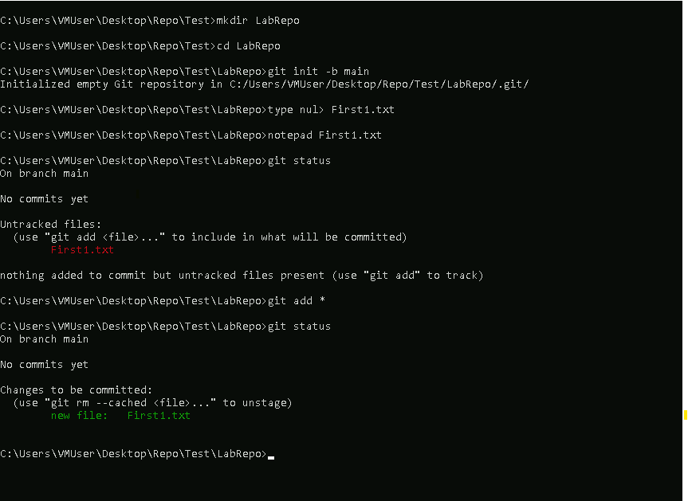

Commit and push the changes in remote repo

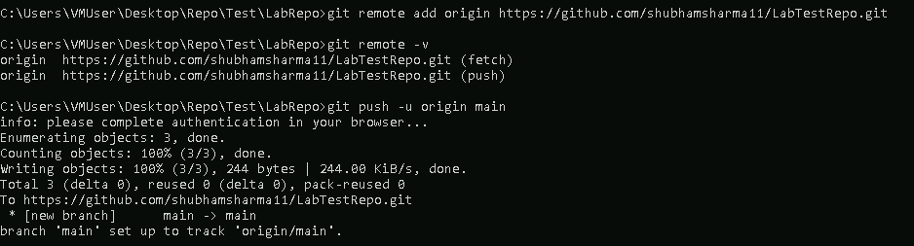

Add second line in file in github master and commit

Pull in the local repo

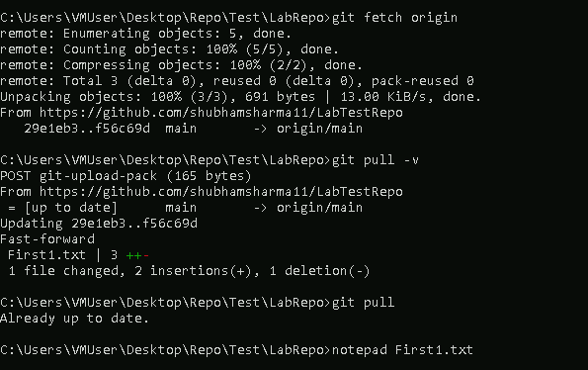

Add the 3rd line in file in remote master

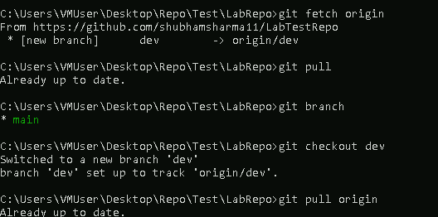

Add the 5th line in file in local dev branch



Push the local branch to github

Merge the branch to master on the githubp

